Drill: Wrist/Elbow (Throwing Series - Part 1)
Purpose:
Develops players use of wrist and elbow along with emphasizing the correct grip on the baseball.
Equipment:
Baseballs
Setup:
Players pair up with gloves and 1 baseball for each pair.
Execution:
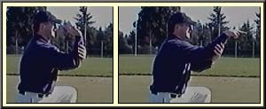
Players get on one knee about 6 feet from their partner. Have each player place their glove on the ground in front of them.
Start by showing the players the proper 4 seam grip on the baseball.
The player with the ball will get the proper grip on the baseball. The player will then bend his elbow and hold his forearm with his other hand.
The player will then bend his wrist back and flick the ball to his partner using only the wrist to throw the ball. Emphasize that the wrist will be used during all throws.
Have players aim for the others players glove as a target.
Have the players back up to about 15 feet.
This time the player throwing the ball will place his other hand under his arm holding his triceps.
The player will then throw the ball using just his elbow and wrist.
